Ethical approval
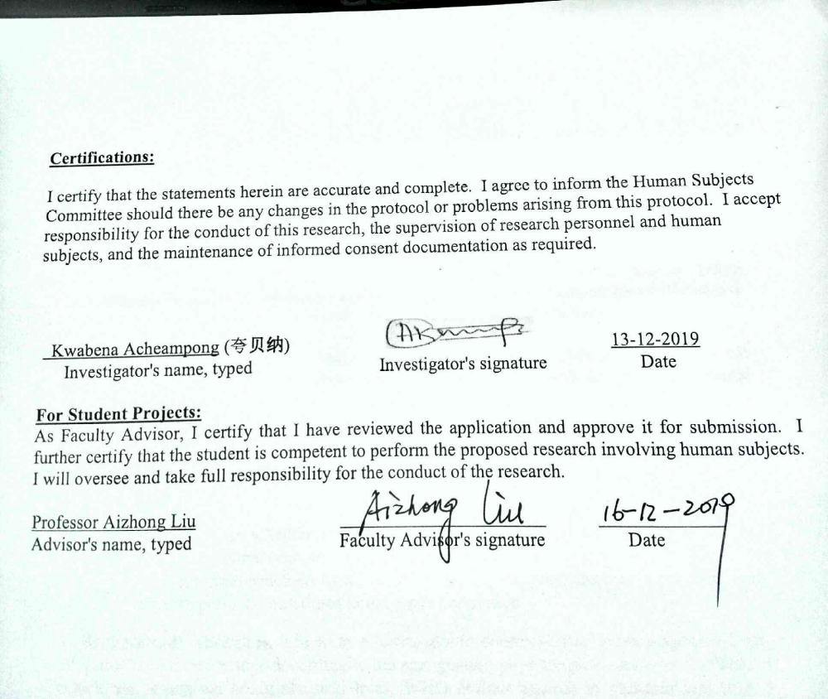

Funding Source
2018年度湖南省重点研发计划-社会发展领域重点研发项目：2018SK2060、妇幼健康大型队列及疾病防控研究-2018SK2065、产妇分娩后健康变化及其影响因素研究
2018 Hunan Provincial Key R & D Plan-Key R & D Projects in Social Development: 2018SK2060, Maternal and Child Health Large Cohort and Disease Prevention and Control Study-2018SK2065.

